Parental Engagement in Marjory Kinnon School 2021-2022

Marjory Kinnon School values good relationships with parents and carers. We offer a range of parent and carer programmes, workshops and coffee mornings throughout the academic year. We aim to provide a range of services that encompass both educational and practical sessions, as well as opportunities for parents to share their own knowledge and expertise and gain support from one another.

In 2021-22, 82 out of 310 parents/carers (26%) returned the questionnaire. Large majority of parents responded positively to the 13 questions.
99% of our parents/carers agreed that their child feels safe at school. 97% agreed that their child makes good progress and 99% said their child is well looked after and taught well in our school.
Their feedback was discussed during the Annual Review meeting to allow the teacher to address any concerns raised.

Some of the analysis of the annual feedback:
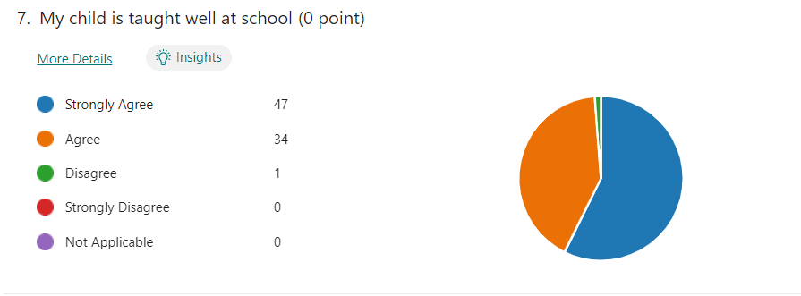
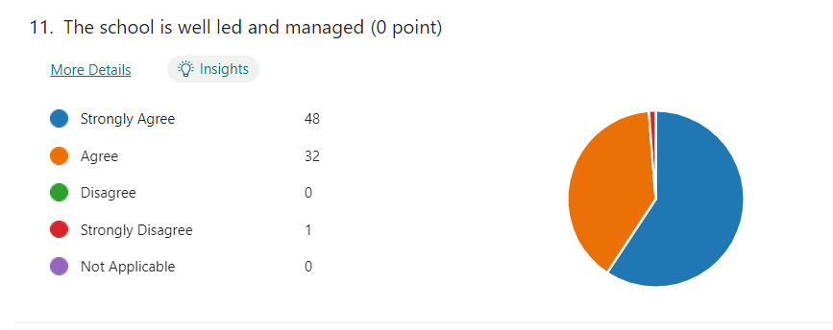
Source: Annual review feedback sheet 2021-2

Teaching/Learning Workshops

During the school year we offer a range of workshops to support the work done in school around communication, structure, socialisation and independence. For example, experienced staff host workshops to support parents to understand their children’s needs with ASC (Autism Spectrum Condition) or external companies to cover specific topics e,g.: sleeping difficulties or oral hygiene as well as subject teachers deliver workshops to support parents understanding on how to read books and how complete maths activities effectively with their child.

There has been an increase of the number of workshops and an increase of parental interest of workshops since lockdown. We kept some of our workshops remotely but vast majority of them are now face to face again.

In 2021-22, 102 parents attended altogether our 5 workshops.
- 99% of the parents felt that there would be a positive impact on their children’s learning or behavior after implementing knowledge of used strategies from the workshops.
- 99% felt that the workshops were practical to their needs and interest.

A sample of comments from workshop feedback sheets:

“All learnt strategies helped me to understand my son’s needs and I am more confident to support him.”
“I cannot THANK YOU enough for your time with us and with our kids! BIG THANK YOU! ”
“I feel this course was excellent, very informative and educational.”
“It was very helpful workshop and I am pleased I attended.”
“Amazing to see and hear that Marjory Kinnon School’s professionals do this program for our kids.”

As part of our community engagement, we invited staff and parents to sign up for weekly group run sessions to train for the Hampton Court Palace 10k. We had a good turnout of enthusiastic beginner and improver runners each week. The initiative was so popular, our training sessions were expanded to include a staff walking group who wanted to join in the fun and get fit.
We had 27 runners complete the 10k which included parents, staff and our Chair of Governors. Thanks to the efforts of everyone involved, our fundraising was very successful and we raised just under £3k for bilingual books for the school’s Library.

Next steps:

To increase parental engagement we will reintroduce regular half-termly coffee mornings and we continue providing a wide range of workshops to parents/carers. To encourage parents more to complete annual feedback sheet.

